**ASSIGNMENT#2**

**NAME:** Muzzammil Ehsan Faheem

**REG ID:** 41917

**PROGRAM:** BS(SE)

**COURSE:** Software Construction

**INSTRUCTOR:** Dr. Nadeem Ahsan & Farooq Iqbal

Introduction:

This is a straightforward adding machine expand on obscure ide utilizing java

Necessities

The number cruncher has the accompanying keys: 0..9, ., +, -, *,/, ±, =, C. In any circumstance, the adding machine needs to deliver the right outcome characterized by the notable number of juggling rules. On the off chance that the counts are unimaginable, the mini-computer needs to show data helping the client to determine the incorrect circumstance, as • On experiencing a division by 0, the showcase should peruse "Can't isolate by 0" and composing the key "C" should reset the mini-computer. On wrong operand or activity keys, the showcase should peruse "Reset (C) to proceed" or "Clear (CE) to proceed" as suitable. Obviously, any circumstance can be cleared utilizing the primary reset key "C".

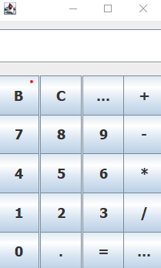

**Project Objective:**

To develop a simple calculator on java which provides:

A simple arithmetic operation

The operation performed are:

Addition

Subtraction

Multiplication

Division

Methods

Introduce java on your machine.

Introduce java ide (for example NetBeans, Eclipse)

Most importantly, I make a design of how I need my mini-computer to resemble.

When the format finishes I began coding and utilizing shroud window developer I make the design of the adding machine.

Presently proceeding further, I need to check all keys are playing out all activity accurately.

Presently I add some rationale so we can connect at least two numbers and add rationale to perform fundamental number-crunching activity.

When coding gets finished I run and troubleshoot mine code and wow incredible adding machine begins working

**What I learned:**

Java programming

Eclipse

Java swing

How to push code on github.

**General learning:**

How to design and implement coding skills.

**Calculator Program Flowchart Showing working of calculator:**

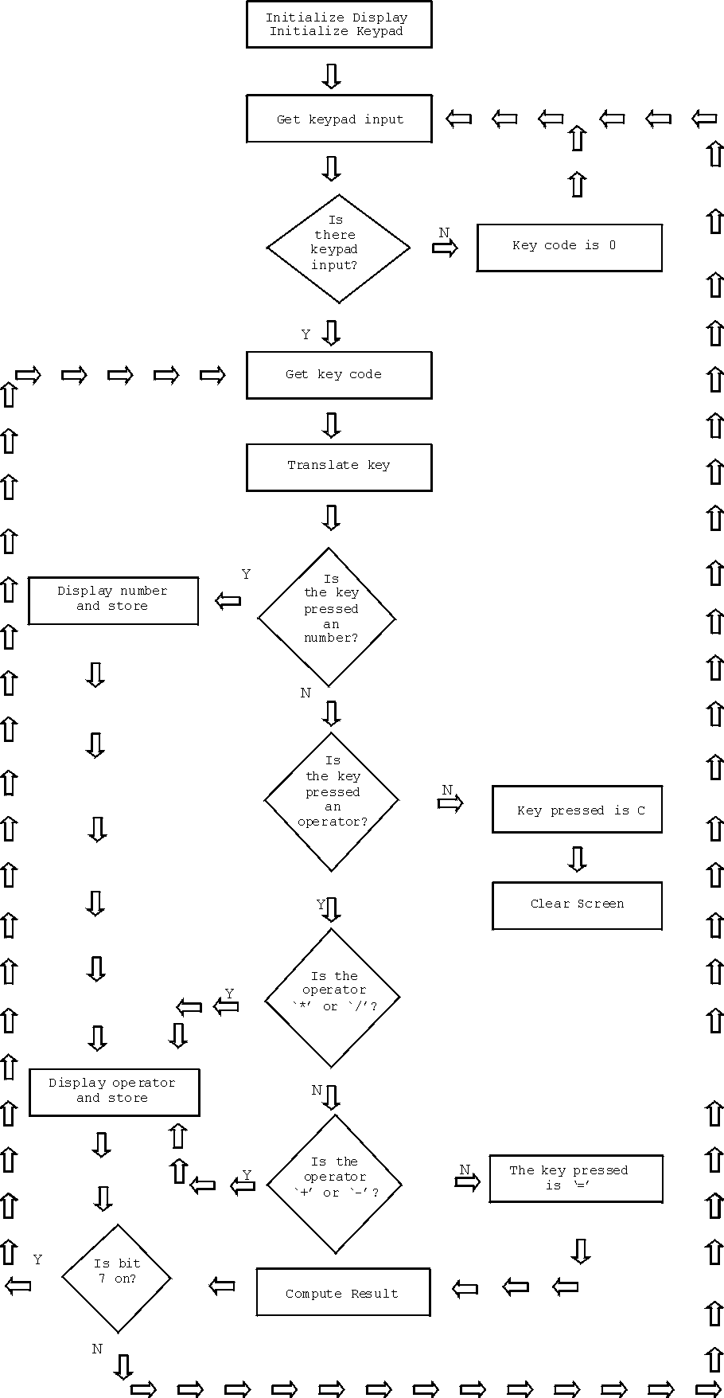

# Program code lines (java) And Gui code:

import java.awt.EventQueue;

import javax.swing.JFrame;

import javax.swing.JTextField;

import javax.swing.JButton;

import java.awt.Font;

import java.awt.TextField;

import java.awt.event.ActionListener;

import java.awt.event.ActionEvent;

public class cal {

double first;

double second;

double result;

String operation;

String fanswer ;

private JFrame frame;

private JTextField textField;

private JButton btn7;

private JButton btn4;

private JButton btn1;

private JButton btn0;

private JButton btnClear;

private JButton btn8;

private JButton btn5;

private JButton btn2;

private JButton btndot;

private JButton btn00;

private JButton btn9;

private JButton btn6;

private JButton btn3;

private JButton btnequal;

private JButton btnPlus;

private JButton btnminus;

private JButton btnmultiply;

private JButton btndivide;

private JButton btnPercentage;

/**

* Launch the application.

*/

public static void main(String[] args) {

EventQueue.invokeLater(new Runnable() {

public void run() {

try {

cal window = new cal();

window.frame.setVisible(true);

} catch (Exception e) {

e.printStackTrace();

}

}

});

}

/**

* Create the application.

*/

public cal() {

initialize();

}

/**

* Initialize the contents of the frame.

*/

private void initialize() {

frame = new JFrame();

frame.setBounds(100, 100, 228, 360);

frame.setDefaultCloseOperation(JFrame.EXIT_ON_CLOSE);

frame.getContentPane().setLayout(null);

textField = new JTextField();

textField.setBounds(0, 11, 217, 44);

frame.getContentPane().add(textField);

textField.setColumns(10);

JButton btnB = new JButton("B");

btnB.setFont(new Font("Tahoma", Font.BOLD, 18));

btnB.setBounds(0, 71, 54, 52);

frame.getContentPane().add(btnB);

btn7 = new JButton("7");

btn7.addActionListener(new ActionListener() {

public void actionPerformed(ActionEvent arg0) {String number = textField.getText()+btn7.getText();

textField.setText(number);

}

});

btn7.setFont(new Font("Tahoma", Font.BOLD, 18));

btn7.setBounds(0, 121, 54, 52);

frame.getContentPane().add(btn7);

btn4 = new JButton("4");

btn4.addActionListener(new ActionListener() {

public void actionPerformed(ActionEvent arg0) {

String number = textField.getText()+btn4.getText();

textField.setText(number);

}

});

btn4.setFont(new Font("Tahoma", Font.BOLD, 18));

btn4.setBounds(0, 172, 54, 52);

frame.getContentPane().add(btn4);

btn1 = new JButton("1");

btn1.addActionListener(new ActionListener() {

public void actionPerformed(ActionEvent arg0) {

String number = textField.getText()+btn1.getText();

textField.setText(number);

}

});

btn1.setFont(new Font("Tahoma", Font.BOLD, 18));

btn1.setBounds(0, 223, 54, 52);

frame.getContentPane().add(btn1);

btn0 = new JButton("0");

btn0.addActionListener(new ActionListener() {

public void actionPerformed(ActionEvent arg0) {

String number = textField.getText()+btn0.getText();

textField.setText(number);

}

});

btn0.setFont(new Font("Tahoma", Font.BOLD, 18));

btn0.setBounds(0, 273, 54, 52);

frame.getContentPane().add(btn0);

btnClear = new JButton("C");

btnClear.addActionListener(new ActionListener() {

public void actionPerformed(ActionEvent arg0) {

textField.setText(null);

}

});

btnClear.setFont(new Font("Tahoma", Font.BOLD, 18));

btnClear.setBounds(55, 71, 54, 52);

frame.getContentPane().add(btnClear);

btn8 = new JButton("8");

btn8.addActionListener(new ActionListener() {

public void actionPerformed(ActionEvent arg0) {

String number = textField.getText()+btn8.getText();

textField.setText(number);

}

});

btn8.setFont(new Font("Tahoma", Font.BOLD, 18));

btn8.setBounds(55, 121, 54, 52);

frame.getContentPane().add(btn8);

btn5 = new JButton("5");

btn5.addActionListener(new ActionListener() {

public void actionPerformed(ActionEvent arg0) {

String number = textField.getText()+btn5.getText();

textField.setText(number);

}

});

btn5.setFont(new Font("Tahoma", Font.BOLD, 18));

btn5.setBounds(55, 172, 54, 52);

frame.getContentPane().add(btn5);

btn2 = new JButton("2");

btn2.addActionListener(new ActionListener() {

public void actionPerformed(ActionEvent arg0) {

String number = textField.getText()+btn2.getText();

textField.setText(number);

}

});

btn2.setFont(new Font("Tahoma", Font.BOLD, 18));

btn2.setBounds(55, 223, 54, 52);

frame.getContentPane().add(btn2);

btndot = new JButton(".");

btndot.addActionListener(new ActionListener() {

public void actionPerformed(ActionEvent arg0) {

String number = textField.getText()+btndot.getText();

textField.setText(number);

}

});

btndot.setFont(new Font("Tahoma", Font.BOLD, 18));

btndot.setBounds(55, 273, 54, 52);

frame.getContentPane().add(btndot);

btn00 = new JButton("00");

btn00.addActionListener(new ActionListener() {

public void actionPerformed(ActionEvent arg0) {

String number = textField.getText()+btn00.getText();

textField.setText(number);

}

});

btn00.setFont(new Font("Tahoma", Font.BOLD, 18));

btn00.setBounds(110, 71, 54, 52);

frame.getContentPane().add(btn00);

btn9 = new JButton("9");

btn9.addActionListener(new ActionListener() {

public void actionPerformed(ActionEvent arg0) {

String number = textField.getText()+btn9.getText();

textField.setText(number);

}

});

btn9.setFont(new Font("Tahoma", Font.BOLD, 18));

btn9.setBounds(110, 121, 54, 52);

frame.getContentPane().add(btn9);

btn6 = new JButton("6");

btn6.addActionListener(new ActionListener() {

public void actionPerformed(ActionEvent arg0) {

String number = textField.getText()+btn6.getText();

textField.setText(number);}

});

btn6.setFont(new Font("Tahoma", Font.BOLD, 18));

btn6.setBounds(110, 172, 54, 52);

frame.getContentPane().add(btn6);

btn3 = new JButton("3");

btn3.addActionListener(new ActionListener() {

public void actionPerformed(ActionEvent arg0) {

String number = textField.getText()+btn3.getText();

textField.setText(number);

}

});

btn3.setFont(new Font("Tahoma", Font.BOLD, 18));

btn3.setBounds(110, 223, 54, 52);

frame.getContentPane().add(btn3);

btnequal = new JButton("=");

btnequal.addActionListener(new ActionListener() {

public void actionPerformed(ActionEvent arg0) {

String answer;

second=Double.parseDouble(textField.getText());

if(operation=="+") {

result=first+second;

answer=String.format("%.2f",result);

textField.setText(answer);

}

else if(operation=="-") {

result=first-second;

answer=String.format("%.2f", result);

textField.setText(answer);

}

else if(operation=="*") {

result=first*second;

answer=String.format("%.2f", result);

textField.setText(answer);

}

else if(operation=="/") {

result=first/second;

answer=String.format("%.2f", result);

textField.setText(answer);

}

}

});

btnequal.setFont(new Font("Tahoma", Font.BOLD, 18));

btnequal.setBounds(110, 273, 54, 52);

frame.getContentPane().add(btnequal);

btnPlus = new JButton("+");

btnPlus.addActionListener(new ActionListener() {

public void actionPerformed(ActionEvent arg0) {

first =Double.parseDouble(textField.getText());

textField.setText("");

operation="+";

}

});

btnPlus.setFont(new Font("Tahoma", Font.BOLD, 18));

btnPlus.setBounds(163, 71, 54, 52);

frame.getContentPane().add(btnPlus);

btnminus = new JButton("-");

btnminus.addActionListener(new ActionListener() {

public void actionPerformed(ActionEvent arg0) {

first =Double.parseDouble(textField.getText());

textField.setText("");

operation="-";

}

});

btnminus.setFont(new Font("Tahoma", Font.BOLD, 18));

btnminus.setBounds(163, 121, 54, 52);

frame.getContentPane().add(btnminus);

btnmultiply = new JButton("*");

btnmultiply.addActionListener(new ActionListener() {

public void actionPerformed(ActionEvent arg0) {

first =Double.parseDouble(textField.getText());

textField.setText("");

operation="*";

}

});

btnmultiply.setFont(new Font("Tahoma", Font.BOLD, 18));

btnmultiply.setBounds(163, 172, 54, 52);

frame.getContentPane().add(btnmultiply);

btndivide = new JButton("/");

btndivide.addActionListener(new ActionListener() {

public void actionPerformed(ActionEvent arg0) {

first =Double.parseDouble(textField.getText());

textField.setText("");

operation="/";

}

});

btndivide.setFont(new Font("Tahoma", Font.BOLD, 18));

btndivide.setBounds(163, 223, 54, 52);

frame.getContentPane().add(btndivide);

btnPercentage = new JButton("%");

btnPercentage.addActionListener(new ActionListener() {

public void actionPerformed(ActionEvent arg0) {

first =Double.parseDouble(textField.getText());

textField.setText("");

operation="%";

}

});

btnPercentage.setFont(new Font("Tahoma", Font.BOLD, 18));

btnPercentage.setBounds(163, 273, 54, 52);

frame.getContentPane().add(btnPercentage);

}

}

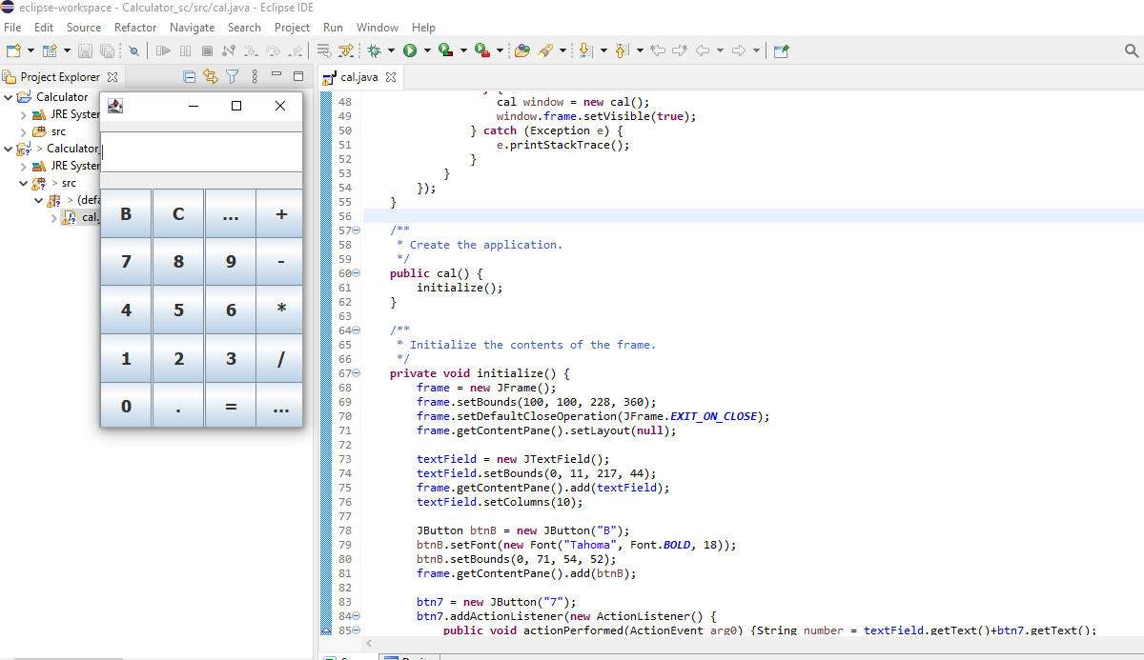

# **GitHub link of my project:**